Python File Handling
Python has several functions for creating, reading, updating, and deleting files.
- The key function for working with files in Python is the open() function.
- The open () function takes two parameters; filename, and mode.

There are four different methods (modes) for opening a file:
- "r" - Read - Default value. Opens a file for reading, error if the file does not exist.
- "a" - Append - Opens a file for appending, creates the file if it does not exist.
- "w" - Write - Opens a file for writing, creates the file if it does not exist.
- "x" - Create - Creates the specified file, returns an error if the file exists.

In addition you can specify if the file should be handled as binary or text mode:-
- "t" - Text - Default value. Text mode
- "b" - Binary - Binary mode (e.g. images)

How to open File
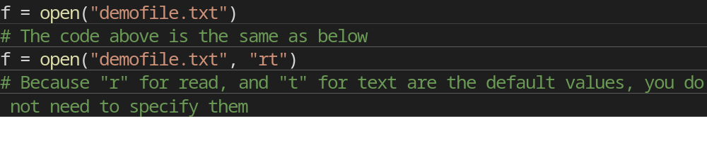
Note: Make sure the file exists, or else you will get an error.

Read a File
Create a Text Document named demofile.txt in a folder. Write down the contents below in this file.
Hello! Welcome to demofile.txt
This file is for testing purposes.
Good Luck!!

To open the file, use the built-in open() function.
The open() function returns a file object, which has a read() method for reading the content of the file:
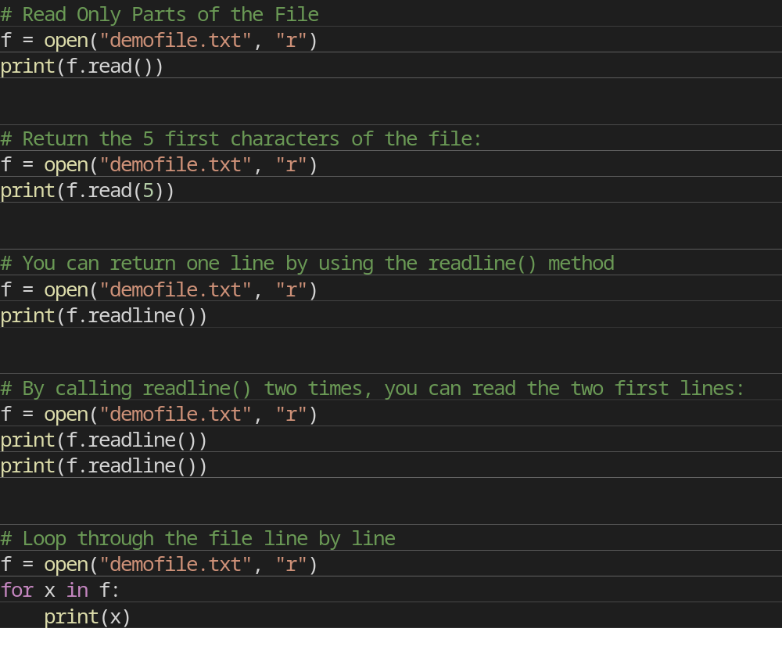

Write to an Existing File
To write to an existing file, you must add a parameter to the open() function:
- "a" - Append - will append to the end of the file.
- "w" - Write - will overwrite any existing content.

Using “w” overwrite method
This will delete all the data existing in that file and write new contents to it.
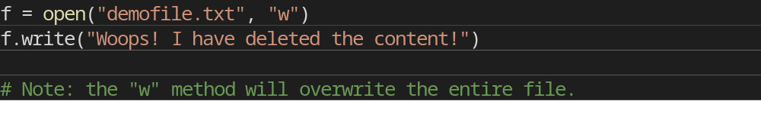
Using “a” overwrite method
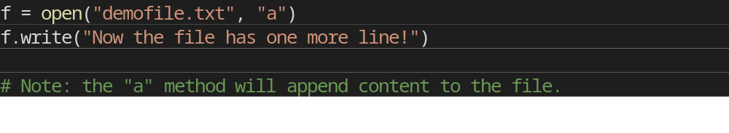

Create New File
To create a new file in Python, use the open() method, with one of the following parameter:
- "x" - Create - will create a file, returns an error if the file exist.
- "a" - Append - will create a file if the specified file does not exist.
- "w" - Write - will create a file if the specified file does not exist.

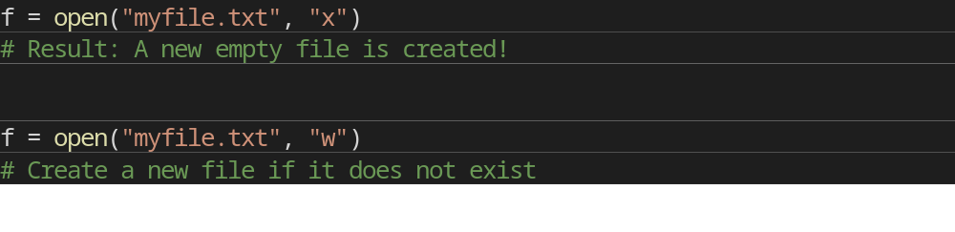

Delete a File
To delete a file, you must import the OS module, and run its os.remove() function:
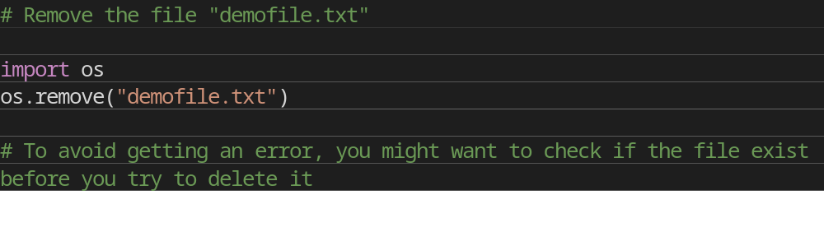
Example to first check if File exists and then delete it.
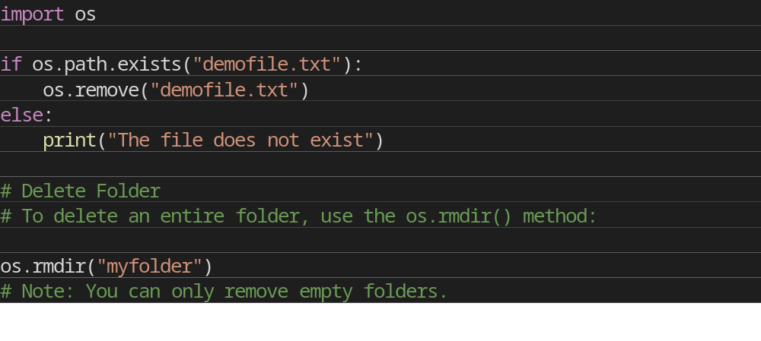
Questions
- Take the Input from the User and write that input into a File.
- There are 2 files (file1.txt & file2.txt). Copy all the contents of File1 into File2.
- Ask 10 words from User. Write all the Odd Length words in odd.txt and Even Length words in even.txt.
- Count the number of words in a whole File.
- Ask a word from User. Replace all the occurrence of that word in the File with “INDIA”.
- Remove all the spaces from a File using File Handling.

